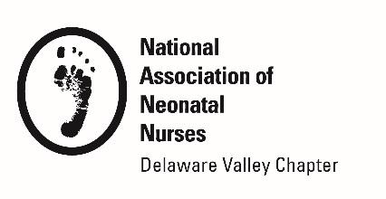

REACH AWARD

NOMINATION APPLICATION

Purpose:

- To recognize and encourage nurses who reach further to touch lives. The annual Reach Award Recipient will be announced each November at DVANN’s Annual Conference. The award will honor and recognize one nurse who has been nominated for her motivation to advance the practice of nursing in one of five categories.

Requirements: A nominee should:

- Be a current NANN Member
- Be a current DVANN Member

Selection Criteria: A nominee should show exemplary drive in ANY ONE category:

- (R) Research: Exploring research practice issues
- (E) Education: supporting creative and unique educational tools
- (A) Advancing Beside Nursing: Advancing skills that drive bedside nursing
- (C) Community Interest: Assessment and community intervention
- (H) Humanitarianism: Patient/professional advocacy and compassion

Award Recognition:
- One year complimentary membership in NANN and DVANN
- A complimentary DVANN conference registration
- Recognition in Preemie Press

Application Instructions:
- Please complete application form and submit all required material to
dvannurses@gmail.com

Submission Deadline is September 1, 2019

REACH AWARD
NOMINATION APPLICATION

Nomination Letter:
- Clearly address the selection criteria and provide specific examples of how the nominee has demonstrated exemplary drive in ANY of the five categories of REACH. Include examples of impact on patients and nursing practice. Nomination letter cannot exceed 2 pages of application.

Signature/Date

NOMINATOR INFORMATION

Name/Credentials

REACH AWARD
NOMINATION APPLICATION

Job Title

Affiliation

Mailing Address

Phone

DVANN Membership Expiration NANN Membership Expiration

Email

Signature/Date

NOMINEE INFORMATION

Name/Credentials

Job Title

Affiliation

Mailing Address

Phone

DVANN Membership Expiration NANN Membership Expiration

Email

Signature/Date

